A Data-Driven Framework for EUDR Commodity-Exposure Identification and Due Diligence Statement Analytics

Shreeja Kalathur, Dalia Robin Dias and Soundhar Karthik Veerapandian
A Capstone submitted to University College Dublin in part fulfilment of the requirements of the degree of M.Sc. in Business Analytics
Michael Smurfit Graduate School of Business, University College Dublin August 2026
Supervisors: Dr. Hippolyte Lefebvre and Mr. Brian Minehane

Dedication
This work is dedicated to our families, whose support made this year of study possible.

Table of Contents
Dedication 2
List of Figures 6
List of Tables 7
Acknowledgements 8
Executive Summary 9
The Challenge 9
Key Findings 9
Recommendations 9
What Has Been Delivered 10
List of Important Abbreviations 11
Chapter 1 - Introduction 12
1.1 Background and Sponsor Context 12
1.2 Problem Statement 12
1.3 Research Question and Objectives 12
1.4 Structure of this Report 13
Chapter 2 - Literature Review 14
2.1 The EUDR and Supply-Chain Due Diligence 14
2.2 Traceability Systems and Enabling Technology 14
2.3 Carbon Accounting, Scope 3 and Input-Output Analysis 14
2.4 Classification Systems 15
2.5 Analytics Methods and Synthetic Data 15
2.6 Afforestation and the Restoration Side of EU Forest Policy 15
2.7 Identified Gap 16
Chapter 3 - Methodology 17
3.1 Research Approach: Design Science Research 17
3.2 Design Requirements 17
3.3 Design Principles 18
3.4 Process Framework: CRISP-DM 19
3.5 The Use of Synthetic Data 20
Chapter 4 - Data 21
4.1 Datasets 21
4.2 Data Preparation 21
Chapter 5 - Design and Development of the Artefact 23
5.1 Business and Data Understanding 23
5.2 Data Preparation I: Commodity-Exposure Mapping (instantiating DP1) 23
5.3 Modelling I: Packaging Carbon Footprint Estimation 25
5.4 Data Preparation II: The DDS Data Model (instantiating DP2) 25
5.5 Deployment I: Database Implementation 26
5.6 Data Preparation III: Synthetic Statement Generation (instantiating DP3) 26
5.7 Modelling II: Rule-Based Validation Layer (instantiating DP5) 27
5.8 Modelling III: Volume Forecasting 27
5.9 Modelling IV: Machine-Learning Document Extraction (instantiating DP4) 28
5.10 Deployment II: Reporting Layer 29
Chapter 6 - Results and Evaluation 30
6.1 Measured Results 30
6.2 Triangulation against the Audited Repak Statement 30
6.3 Benchmarking of Modelling Choices 32
6.3.1 Classifier comparison and generalisation 33
6.3.2 Forecast model comparison 33
6.3.3 Validation layer as a detector 34
6.4 Evaluation of the Design Principles 34
Chapter 7 - The EUDR Compliance Analytics Framework 36
7.1 What the Framework Contributes 36
7.2 The Six Stages 36
7.3 Conditions of Applicability 38
Chapter 8 - Contribution, Discussion and Limitations 39
8.1 Contribution to Knowledge 39
8.2 Discussion in Relation to Prior Work 39
8.3 Limitations 40
Chapter 9 - Conclusions and Recommendations 42
9.1 Conclusions 42
9.2 Recommendations for the Sponsor 42
9.3 Future Work 42
References 43
Appendix A - Project Timeline 46
Appendix B - Additional Materials 47
Appendix C - Synthetic Data Generation Specification 48
Glossary of Terms 50

List of Figures

Figure 1 — Methodological nesting: Design Science Research and CRISP-DM
Figure 2 — Commodity-exposure map: 14 of 81 own-brand products in EUDR scope
Figure 3 — 2024 packaging carbon footprint by material
Figure 4 — The 19-field DDS data model derived from EUDR Annex II
Figure 5 — Composition of the synthetic register and the validation outcome
Figure 6 — Monthly DDS volume, fitted trend and twelve-month forecast
Figure 7 — The Power BI compliance dashboard
Figure 8 — Material-mix triangulation against the audited Repak declaration
Figure 9 — Benchmarking of modelling choices: classifier and forecast comparison Figure 10 — The implemented pipeline as evidence for the six framework stages

List of Tables

Table 1 — Datasets provided by the sponsor and their role in the project
Table 2 — Commodity-exposure classification outcome by evidence type
Table 3 — Measured results across all system components
Table 4 — Material tonnages: computed estimate versus audited Repak statement
Table 5 — Project timeline and deliverables by week

Acknowledgements

We gratefully acknowledge Stonehouse Marketing Limited for sponsoring this project and for providing the product, packaging and volume datasets on which the analysis rests. We thank Mr. Brian Minehane, our industry supervisor, for his guidance throughout, for the domain knowledge that corrected our classification of the firelighter product range, and for directing the project toward commodity exposure as its primary focus. We thank Dr Hippolyte Lefebvre, our academic supervisor, for his guidance in framing the research question and positioning the framework as the principal deliverable of the work.

Executive Summary

The Challenge
From 30 December 2026, the EU Deforestation Regulation prohibits Stonehouse Marketing Limited from placing own-brand products linked to seven regulated commodities on the EU market unless each is covered by a Due Diligence Statement proving it is deforestation-free. Non-compliance carries penalties of up to four per cent of EU turnover. As operator of the Homestead and White Hat ranges, Stonehouse faced three unanswered questions: which of its 81 own-brand products the regulation catches, how the incoming volume of supplier statements would be checked and analysed, and how its compliance position would be evidenced. No system existed for any of the three, and no real statements exist yet on which to build one.

Key Findings
Exposure is narrower and more concentrated than expected. Fourteen of the 81 own-brand products fall within scope, almost entirely in two areas: wood-based lines, comprising toilet tissue, firelogs and firelighters, and the Paws pet-food range. The remaining 67 products require no due-diligence action, which means compliance effort can be directed at a small, identifiable group of suppliers rather than the whole range.
Compliance workload will grow steadily rather than arriving as a one-off. Statement volumes are projected to reach approximately 60 per month by early 2028, indicating that compliance capacity should be sized for growth as suppliers progressively onboard.
Data quality will be a material operational issue. Applied to a test register of 1,000 statements, automated checking cleared 818 and flagged 182 for review. Critically, these divide into two groups requiring different responses: 63 were structurally defective and require correction with the supplier, while 119 were complete statements missing an upstream reference, representing genuine gaps in the due diligence chain.
Deforestation compliance and carbon reduction target the same materials. Approximately 92 per cent of the own-brand packaging carbon footprint derives from paper and wood, the same material stream that dominates EUDR exposure, so investment in both agendas advances both. The figure has been validated against the company's audited Repak declaration, as set out in Section 6.2.

Recommendations
Four actions follow. First, obtain supplier confirmation for the four product classifications currently resting on market-comparable evidence, so the exposure register can be relied upon for filing. Second, clarify the Repak declaration boundary and the treatment of reuse packaging, which would resolve the outstanding question over the absolute footprint figure. Third, size compliance resourcing against a growing rather than a steady workload. Fourth, begin collecting supplier documentation ahead of the December 2026 commencement, since the automated intake component can be trained on real documents as soon as they are available.

What Has Been Delivered
A working compliance analytics capability comprising a product exposure register, a statement database derived from the regulation's own requirements, automated validation, volume forecasting, automated document reading, and an interactive Power BI dashboard. Because no real statements yet exist, the system was built and tested on 1,000 synthetic statements calibrated to Stonehouse's actual supplier and volume data; it will accept real statements without redesign. The underlying method is documented as a framework that other operators facing similar EUDR obligations could potentially adapt.

List of Important Abbreviations

CRISP-DM | Cross-Industry Standard Process for Data Mining
DDS | Due Diligence Statement
DSR | Design Science Research
EEIO | Environmentally Extended Input-Output
ESPR | Ecodesign for Sustainable Products Regulation
EUDR | EU Deforestation Regulation (Regulation (EU) 2023/1115)
GHG | Greenhouse Gas
HS code | Harmonised System code (product classification)
LULUCF | Land Use, Land-Use Change and Forestry
NACE | Statistical Classification of Economic Activities in the European Community
OLS | Ordinary Least Squares
PPWR | Packaging and Packaging Waste Regulation
SKU | Stock Keeping Unit
TF-IDF | Term Frequency–Inverse Document  Frequency

Chapter 1 - Introduction

1.1 Background and Sponsor Context
The EU Deforestation Regulation came into operation on 29 June 2023. It prohibits the placing on the Union market, and the export from it, of cattle, cocoa, coffee, oil palm, rubber, soya and wood, together with derived products such as leather, chocolate, tyres and furniture, unless those products are deforestation-free, have been produced in accordance with the relevant legislation of the country of production, and are covered by a Due Diligence Statement (European Parliament and Council, 2023). The application of these obligations has been postponed twice, and they now apply to large and medium operators from 30 December 2026 and to micro and small operators from 30 June 2027. A simplification package published on 4 May 2026 introduced further measures that include country risk benchmarking and a rule under which only the first operator in a supply chain files a full statement. The regulation distinguishes between operators who place products on the market for the first time and carry the full due-diligence obligation, and traders further down the chain who face lighter record-keeping requirements.
Stonehouse Marketing Limited is an Irish wholesale and distribution group. Its own-brand ranges, Homestead and White Hat, comprise 81 products, and in respect of these Stonehouse acts as an operator, meaning that it will both file and receive Due Diligence Statements in volume. For the third-party brands it distributes, it acts as a trader. When this project began in May 2026, the company had no reliable means of answering three questions: which own-brand products the regulation covers, how incoming statements would be received, checked and analysed at scale, and how the overall compliance position would be reported. The company had calculated its Scope 1 and Scope 2 emissions under ISO 14064, but Scope 3 emissions for the own-brand ranges had not been assessed.

1.2 Problem Statement
Stonehouse Marketing Limited will be subject to EUDR obligations from December 2026 and will receive Due Diligence Statements in volume from its suppliers. It has no systematic means of identifying which of its own-brand products carry exposure to the regulated commodities, of ingesting and validating incoming statements, or of reporting its compliance position.

1.3 Research Question and Objectives
The research question guiding this project is: how can a data-driven framework be designed to identify exposure to deforestation-risk commodities and to track and analyse Due Diligence Statements, in a way that supports EUDR- and ESPR-aligned compliance, within the context of a food wholesaler's own-brand product range? The question sits at the intersection of regulatory compliance and data-systems design, because the challenge is not simply to understand what the regulation requires, but to build something practical that a mid-sized company can use to meet those requirements at scale.
Four sub-questions make the research question tractable. The first asks which EUDR commodities and derived products appear in the own-brand range, and how products can be systematically mapped against them rather than through manual checks that would not scale. The second asks what data structure, grounded in Annex II of the regulation, can represent a Due Diligence Statement in a manner both faithful to the legislation and usable for analysis, and how realistic synthetic statements can be generated where no real data exists. The third asks how the framework can validate the quality of incoming data, catching errors before they become compliance risks, and how it can forecast future statement volumes to support resource planning. The fourth asks how the framework relates to the wider EU regulatory regime, including the Ecodesign for Sustainable Products Regulation, and whether its design generalises to other companies facing the same obligations.
Following guidance from the sponsor, commodities are treated as the primary focus of the analysis, with the carbon assessment playing a supporting role. Both product content and packaging are assessed, but the two are kept distinct by regulatory regime: product content is assessed under the EUDR, where deforestation-linked commodities are directly regulated, while packaging is assessed through the lens of carbon accounting and packaging regulation, reflecting the different rules that apply to each.

1.4 Structure of this Report
Chapter 2 reviews the literature across six thematic pillars and identifies the research gap. Chapter 3 sets out the methodology, deriving the design requirements and design principles that guide the work. Chapter 4 describes the data and its preparation. Chapter 5 documents the design and development of the artefact, organised by CRISP-DM phase. Chapter 6 presents the results and evaluation, including triangulation against an independent audited source, benchmarking of the modelling choices, and evaluation of the design principles. Chapter 7 presents the framework, the principal deliverable of the work. Chapter 8 states the contribution, discusses the findings in relation to prior work, and sets out the limitations. Chapter 9 concludes and provides recommendations and future work. Supporting material, including the project timeline and the synthetic data generation specification, is provided in the appendices.

Chapter 2 - Literature Review

This chapter reviews the literature across the fields on which the project draws, organised into six thematic pillars and triangulating academic, official and practitioner sources. The literature search was conducted between 8 June and 28 June 2026 using Google Scholar, Scopus and the UCD library databases, together with primary legislative and standards documents. Regulatory statements are current as at 25 July 2026, a caveat that matters because the implementing detail of the EUDR has changed repeatedly during the project period.

2.1 The EUDR and Supply-Chain Due Diligence
The primary source is the regulation itself (European Parliament and Council, 2023), together with the Commission's implementation guidance and frequently asked questions (European Commission, 2026). Gilbert (2024) provides a peer-reviewed overview of the regulation's objectives and commodity scope and is useful for establishing the policy rationale. McDermott et al. (2025) propose a monitoring framework for the EUDR and interrogate the equity implications of unilateral value-chain policy for producer countries; their framework offers a benchmark against which the artefact developed here can be positioned, although their focus is on macro-level policy monitoring rather than on firm-level compliance operations. Singh, Siddiqui and Prasad (2025) examine evolving disclosure and governance responses in a producer-country context, extending the view beyond the EU perspective. Because the regulation is recent, this pillar necessarily draws more heavily on official sources than on a settled peer-reviewed corpus; that imbalance is a characteristic of the field at present rather than a gap in the search strategy.

2.2 Traceability Systems and Enabling Technology
Reading et al. (2024) demonstrate due diligence for deforestation-free supply chains using Copernicus Sentinel-2 imagery and machine learning, anchoring the geospatial verification dimension implied by the regulation's requirement for plot-level geolocation. Rothe et al. (2024) present the EUDR Coffee Check, a compliance-support tool developed for a single commodity, and Wibawa et al. (2024) describe a palm-oil commodity traceability information system built explicitly to support EUDR implementation in Indonesia. The latter is the closest system-level precedent to the artefact developed here. Both, however, are commodity-specific: neither addresses the position of a wholesaler holding a mixed own-brand range spanning several regulated commodities, which is the situation this project addresses.

2.3 Carbon Accounting, Scope 3 and Input-Output Analysis
The supporting footprint analysis rests on the GHG Protocol Corporate Value Chain (Scope 3) Standard (WRI and WBCSD, 2011) and on environmentally extended input-output analysis using the EXIOBASE database. Stadler et al. (2018) document the construction of that database, and Merciai and Schmidt (2018) set out the hybrid supply-use methodology underlying the greenhouse-gas intensity data used here. This literature is explicit that such factors are sector averages rather than product-specific measurements, and that the resulting estimates are appropriate for screening-level analysis rather than for product-level claims. That limitation is carried transparently into the results reported in Chapter 6.

2.4 Classification Systems
NACE Rev. 2 (Eurostat, 2008) provides the classification of economic activities that bridges product materials to EXIOBASE emission-factor sectors and is the mechanism by which the sponsor's requirement to identify NACE codes associated with the own-brand ranges was met. Harmonised System codes, by contrast, define the product scope of the EUDR itself in Annex I of the regulation. The distinction matters in practice: NACE classifies what an economic activity is, while HS codes classify what a product is, and the Due Diligence Statement requires the latter.

2.5 Analytics Methods and Synthetic Data
Forecasting method selection follows Hyndman and Athanasopoulos (2021), whose guidance favours the simplest model that captures the observed pattern, particularly where the series is short. Bommarito, Katz and Detterman (2018) demonstrate combined rule-based and statistical natural-language processing for legal and regulatory text and provide the design precedent for the two-stage document extractor built in this project: deterministic pattern matching for rigidly formatted fields, and statistical classification for free text. The synthetic-data literature supports the generation of realistic test data where real data is unavailable, provided that the generation process is documented, parameterised from real observations where possible, and reproducible. That is the position adopted here.

2.6 Afforestation and the Restoration Side of EU Forest Policy
EU forest policy operates on two fronts, and the sponsor directed that both be addressed. The EUDR polices deforestation by constraining the demand embodied in traded commodities. Afforestation and reforestation form the restoration side: the New EU Forest Strategy for 2030 (European Commission, 2021) carries a pledge to plant at least three billion additional trees in the Union by 2030 in full compliance with ecological principles, while the LULUCF Regulation sets a binding Union-level objective of 310 million tonnes of carbon dioxide equivalent in net removals by 2030, with national budgets applying from 2026 and obligations to expand sinks through afforestation or reforestation where emissions exceed removals (European Parliament and Council, 2018). Progress on the planting pledge has been slow, which underlines that restoration is a decades-long complement to, and not a substitute for, preventing deforestation now. Two connections matter for this project. First, the instruments are complementary halves of a single land-use policy, so a compliance framework serving the preventive half sits naturally within the reporting logic of the restorative half. Second, the LULUCF Regulation explicitly accounts for carbon stored in harvested wood products, which is directly relevant to a product range whose exposure and footprint are both dominated by wood-derived materials.

2.7 Identified Gap
Across these literatures, there is substantial work on EUDR compliance in principle, on traceability technology for individual commodities, and on carbon foot printing as a separate exercise. There is little that operationalises Due Diligence Statement analytics together with commodity-exposure mapping and sector-level carbon estimation for a wholesaler holding a mixed product range, and none identified that presents such an approach as a reusable framework rather than a bespoke system. That integration is the contribution of this project.

Chapter 3 - Methodology

3.1 Research Approach: Design Science Research
This project produces an artefact rather than a theory, and its central question asks how something should be designed. Design Science Research is therefore the appropriate paradigm. Hevner et al. (2004) characterise design science as the creation and evaluation of purposeful artefacts that address organisational problems, and Peffers et al. (2007) operationalise this into six activities: problem identification, definition of solution objectives, design and development, demonstration, evaluation, and communication. Gregor and Hevner (2013) further distinguish the levels at which a design-science contribution may sit, ranging from a specific instantiation, through design principles and methods, to fully developed design theory.
This distinction matters for the present work, because an artefact alone is not a research contribution. A working system demonstrates that something can be built; it does not establish why it should be built that way, nor whether the reasoning transfers to another organisation. The contribution of this project is accordingly positioned at the level of design principles: nascent design knowledge, in the terms of Gregor and Hevner (2013), expressed as prescriptive statements that were derived from the problem, embodied in the artefact, and evaluated through it. Section 3.2 derives the design requirements from the problem context, Section 3.3 states the design principles that respond to them, and Section 6.4 evaluates the artefact against each principle in turn.

3.2 Design Requirements
Five requirements were derived from three sources: the obligations imposed by the regulation itself, the operating constraints of the sponsor organisation, and the conditions under which any such system must be developed before the compliance deadline. They are stated here as requirements rather than features, because each constrains the space of acceptable designs rather than describing a component. DR1. Classification under incomplete evidence. Commodity exposure must be determinable for an entire product range even where ingredient-level specification is unavailable, and every determination must remain traceable to the evidence that produced it. The sponsor holds packaging and volume data but not ingredient composition, and this is the ordinary condition of a wholesaler distributing third-party manufactured goods.
DR2. Regulatory fidelity and durability. The data structure must correspond to the legal requirements it serves and must accommodate amendment without redesign. The EUDR has been amended twice during this project alone, and its implementing detail continues to evolve.
DR3. Development in advance of data. The system must be constructible, testable and demonstrable before any real Due Diligence Statement exists, since obligations commence only in December 2026 and preparation cannot wait for the first statement to arrive.
DR4. Auditability of automated decisions. Where the system makes or supports a compliance determination, the basis of that determination must be inspectable. A determination that cannot be explained to a regulator has limited value irrespective of its accuracy.
DR5. Actionable differentiation of defects. The system must distinguish between records that are defective and records that are complete but non-compliant, because the two route to different remedial actions and conflating them produces either a false alarm or missed exposure.

3.3 Design Principles
Five design principles were formulated in response to these requirements. Each is stated in the prescriptive form recommended for design-science contributions, identifying the action, the context in which it applies, and the mechanism through which it achieves its effect. Each principle is subsequently instantiated in the artefact and evaluated in Section 6.4.
DP1. Tiered evidence provenance. To determine regulated-commodity exposure where authoritative composition data is unavailable, classify against an ordered hierarchy of evidence and record the tier alongside each determination, so that inferred classifications remain distinguishable from confirmed ones and can be revised without disturbing the wider analysis. (Addresses DR1 and DR4.)
DP2. Regulation-derived data structure. To represent a compliance instrument, derive the data model field by field from the legal text that defines it rather than from analyst judgement, so that each field is defensible by reference to the statute and amendments to the statute map onto identifiable fields. (Addresses DR2 and DR4.) DP3. Calibrated synthetic instantiation with seeded defects. To develop and validate a compliance system before real data exists, generate synthetic records parameterised from the organisation's actual operating data and deliberately seed a known proportion of defects, so that the system can be exercised end to end and detection performance measured against a known ground truth. (Addresses DR3.) DP4. Method allocation by field determinacy. To automate the interpretation of compliance documents, allocate deterministic rules to fields whose format is legally prescribed and learned models only to fields whose value depends on meaning, so that most of the extraction remains auditable and statistical inference is confined to where it is genuinely required. (Addresses DR4.)
DP5. Separation of malformity from non-compliance. To screen compliance records, evaluate structural validity and regulatory completeness as distinct conditions and report them separately, so that defective records and non-compliant records are routed to the appropriate remedial process. (Addresses DR5.)
These principles are not descriptions of the components built in Chapter 5. They are prescriptive statements about how a class of problem should be approached, and they are what is transferable from this project to another operator facing the same regulation. The framework presented in Chapter 7 is their organised expression.

3.4 Process Framework: CRISP-DM
Design Science Research prescribes that an artefact be designed, developed, demonstrated and evaluated, but it does not specify how the underlying data work should be organised. The Cross-Industry Standard Process for Data Mining supplies that structure for the design and development activity, through six phases: business understanding, data understanding, data preparation, modelling, evaluation and deployment. The two frameworks operate at different levels and are complementary rather than alternative: Design Science Research governs the research logic, from problem to principles to evaluated contribution, while CRISP-DM governs the execution of the data work within it. Chapter 5 is organised explicitly by CRISP-DM phase so that each is identifiable, and Chapter 6 reports the evaluation phase together with the design-science evaluation of the principles. The relationship is illustrated in Figure 1.
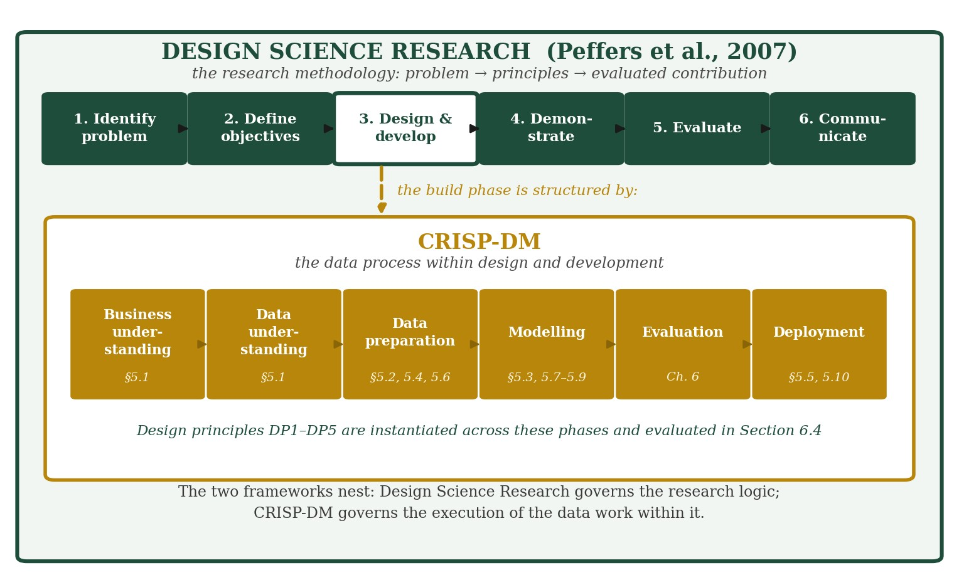
Figure 1 — Methodological nesting: Design Science Research provides the outer research framing; CRISP-DM structures the data work within the design and development phase.

3.5 The Use of Synthetic Data
No real Due Diligence Statement exists before the regulation applies, and the sponsor confirmed at the outset that none would be available during the project. Rather than treating this as a constraint on what could be attempted, it was addressed as a design problem, and the response is stated as DP3. Synthetic statements were generated under a fixed random seed from parameters drawn from the sponsor's real supplier, product and volume records, with approximately ten per cent of records deliberately corrupted.
Three properties follow. The generation is exactly reproducible, so any result reported here can be regenerated. The dataset carries a known ground truth, so detection performance can be measured rather than asserted, which would be impossible with real data of unknown quality. And no real supplier or consignment data is processed at any stage, which removes data-protection exposure entirely. The corresponding limitation, that results obtained on synthetic data are conditional on the assumptions embedded in the generator, is quantified in Section 6.3 and stated in Chapter 9. Full generation parameters are provided in Appendix C.

Chapter 4 - Data

4.1 Datasets
Five datasets were provided by the sponsor at the outset of the project and profiled during Week 4 (8 to 14 June 2026). Their roles are summarised in Table 1.

Dataset | Role in the project
Green Streets packaging specifications 2024 | Primary dataset: 81 own-brand products with suppliers, packaging materials and component weights, and 2024 sales volumes
Repak tonnage statement, full year 2024 | Independently audited packaging tonnages, reserved for the evaluation cross-check
NACE Rev. 2 to EXIOBASE concordance | Bridge from product materials to emission-factor sectors
EXIOBASE hybrid v3.8 greenhouse gas intensities | Sector emission factors in tonnes of carbon dioxide equivalent per tonne, by country
Affiliates list | Geography of the group's 22 member depots
Table 1 — Datasets provided by the sponsor and their role in the project.

4.2 Data Preparation
Data preparation, carried out during Weeks 6 and 8 (22 June to 12 July 2026), addressed several distinct quality issues. Malformed column headers containing line breaks and irregular spacing were normalised so that fields could be referenced reliably throughout the pipeline. Numeric values stored as text, a common artefact of spreadsheet export, were converted to numeric types so that they could enter calculations rather than being treated as strings.
One issue required interpretation rather than a technical fix. The field labelled annual unit volume was found on inspection to record product mass rather than a count of units. Had this been taken at face value, all downstream volume calculations and forecasts would have rested on a mistaken assumption. The true number of units sold was therefore derived by multiplying cases sold by case quantity. This check illustrates why data preparation cannot be a purely mechanical exercise: it must interrogate what a field represents, not only what it is labelled.
Geolocation presented a different problem, rooted in the absence of real data rather than in data quality. In a real Due Diligence Statement, geolocation is supplied by the producer as the coordinates of the plots on which the commodity was grown or harvested. Since no real statements existed, coordinates for the synthetic records were generated within the geographic bounds of the relevant producing country and marked as simulated throughout, so that they could not be mistaken for producer-supplied data. For official reference data, including the country risk benchmarking applied in the framework, the project drew on sources published by the European Commission and the EU open-data portal, so that classifications used in the system are consistent with the actual regulatory position rather than with internally assumed values.

Chapter 5 - Design and Development of the Artefact

This chapter documents the design and development activity of the Design Science Research cycle. It is organised by CRISP-DM phase so that each phase is identifiable, and each section notes which design principle from Section 3.3 it instantiates. Because the components are interdependent, phases recur rather than proceeding strictly once: data preparation, for instance, occurs three times, for the product range, the data model and the synthetic register respectively.

5.1 Business and Data Understanding
The business understanding phase established the compliance problem set out in Chapter 1 and the design requirements derived in Section 3.2, through the initial supervisory meeting in May 2026 and subsequent sponsor consultation. The data understanding phase profiled the five sponsor datasets described in Chapter 4, establishing what each contained, how the files related to one another, and where interpretation was required rather than direct reading. Two findings from this phase shaped everything that followed. First, the sponsor holds packaging and volume data but not ingredient composition, which established DR1 and made an evidence hierarchy necessary rather than optional. Second, the field labelled annual unit volume was found to record product mass rather than a count of units, an interpretation issue documented in Section 4.2 whose consequences are revisited in Section 6.2.
This chapter documents the construction of the artefact, following the sequence in which the components were built between June and July 2026. Each stage depends on the one before it: the exposure map determines which commodities the system must handle; the data model determines what the database stores; the database enables generation, validation, forecasting and reporting in turn.

5.2 Data Preparation I: Commodity-Exposure Mapping (instantiating DP1)
Each of the 81 own-brand products was assessed against a single question: does the product itself contain one of the seven regulated commodities? Two rules were applied throughout. First, product content rather than packaging determines EUDR scope, since packaging used to protect another product is expected to be excluded under the May 2026 draft delegated act. Second, superficially similar products were screened out where the resemblance is misleading; the White Hat vinyl gloves, for instance, are a plastic product and are not within the rubber commodity.
Classification followed an explicit evidence hierarchy, and each verdict records the evidence type on which it rests. The strongest evidence is direct product identity, where the product is definitionally the commodity: toilet tissue is wood pulp, and the beef pet food is a cattle product. The second tier is sponsoring domain knowledge. During Week 10 the industry supervisor confirmed that the flammable substance in the own-brand firelighters is wood-based, which placed all four firelighter products within scope and superseded an earlier classification based on market comparison, under which they had been excluded as petroleum-based. The third tier, used where neither of the first two applies, is equivalent market data drawn from comparable products on the Irish and United Kingdom wholesale market, which implements the sponsor's objective of identifying equivalent market-available data for similar products. On that basis, the Paws pet-food lines were placed in scope, since comparable complete pet foods list soybean meal and cattle derivatives among their ingredients, while a bulk catering oil was classified as probably out of scope, since that market channel is dominated by rapeseed. Verdicts resting on market evidence remain flagged for supplier verification, preserving an audit trail from evidence to decision.
The outcome is that 14 of the 81 products fall within EUDR scope, as summarised in Table 2 and Figure 2. Exposure is concentrated in two areas: wood-based lines, comprising toilet tissue, fire logs and firelighters, and the pet-food range, which carries cattle and soya derivatives.

Verdict | Products | Examples | Evidence tier
In scope, confirmed | 7 | Toilet tissue lines, fire logs, beef pet food | Product identity
In scope, sponsor confirmed | 4 | Firelighters (wood-based flammable substance) | Sponsor domain knowledge
In scope, market proxy | 3 | Paws chicken, complete and tinned pet food | Equivalent market data
Borderline, pending confirmation | 1 | Bulk catering oil, 20 litres | Equivalent market data
Out of scope | 66 | Canned goods, foil, plastics, vinyl gloves | Product identity
Table 2 — Commodity-exposure classification outcome by evidence type.
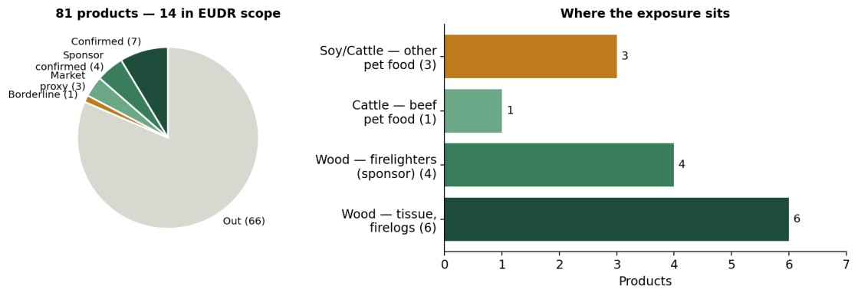
Figure 2 — Commodity-exposure map: 14 of 81 own-brand products in EUDR scope, each verdict carrying its evidence type.

5.3 Modelling I: Packaging Carbon Footprint Estimation
The 2024 packaging carbon footprint was estimated in four steps. Component gram weights were taken from the packaging specifications and multiplied by 2024-unit volumes to give the total mass of each material placed on the market. Each material was then mapped through NACE Rev. 2 to its corresponding EXIOBASE production sector, and the sector greenhouse-gas intensity was applied, using Ireland-specific factors where Ireland produces the material and a documented global-average fallback where it does not, as is the case for basic plastics and steel.
The resulting estimate is approximately 1,040 tonnes of carbon dioxide equivalent (scaled to the full own-brand range; 326 tonnes for the 68 products with volume data), of which 92 per cent derives from paper, card and wood. The finding connects the two regulatory lenses the sponsor asked to be kept distinct: carbon reduction and EUDR wood relevance point to the same material streams, even though different instruments govern them. Consistent with the input-output literature, the figure is a screening-level estimate under stated assumptions rather than a measured inventory. The breakdown by material is shown in Figure 3.
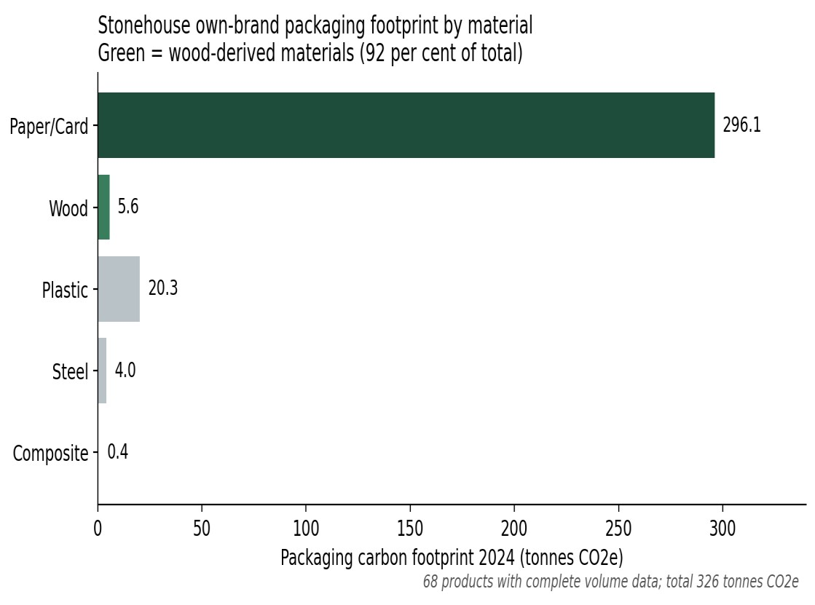
Figure 3 — 2024 packaging carbon footprint by material; wood-derived materials shown in green.

5.4 Data Preparation II: The DDS Data Model (instantiating DP2)
Annex II of the regulation specifies the information that a Due Diligence Statement must contain. Each requirement was translated into a database field, together with the elements introduced by the May 2026 simplification package: the estimated annual quantity, the prior-statement reference that implements the first-operator rule, and the country risk level arising from benchmarking. The resulting model has 19 fields, shown in Figure 4.
Two design features warrant comment. The DDS reference serves as the primary key, so that duplicate statements cannot enter the register. The prior-DDS reference is a self-referencing foreign key: it points to the primary key of another statement, and it is this construction that represents the upstream chain of due diligence, which is precisely the position Stonehouse occupies as a downstream operator receiving statements from suppliers. In a fully normalised production design the supplier field would become a foreign key to a separate suppliers table; it is held as a text field here for prototype simplicity, a simplification stated rather than concealed.

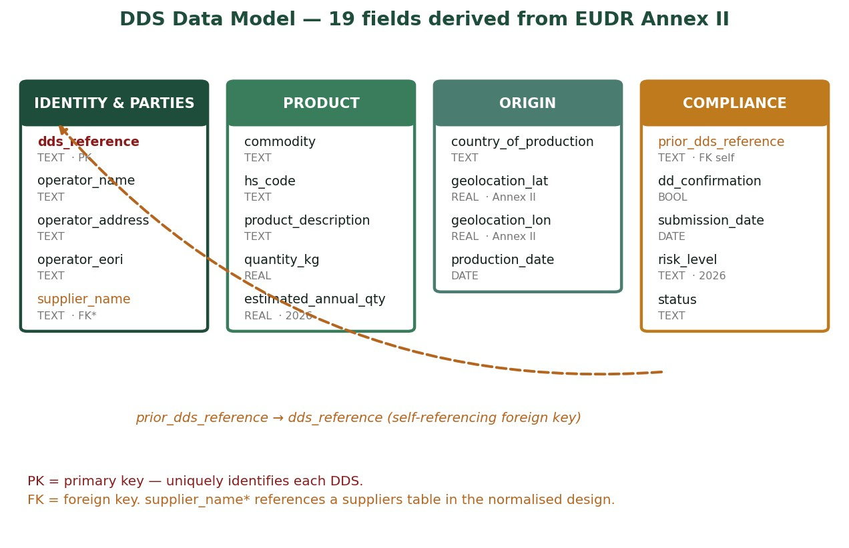
Figure 4 — The 19-field DDS data model derived from EUDR Annex II. The primary key is shown in red and foreign keys in orange, including the self-referencing upstream chain.

5.5 Deployment I: Database Implementation
The model was implemented in SQLite, a relational database engine. The full record lifecycle is supported: statements are created on ingestion, queried for analysis and reporting, and updated when validation assigns a flag. Deletion is implemented as archiving, in which a record is marked inactive rather than removed, in line with the regulation's requirement that statements be retained for five years. SQLite was selected as fit for purpose at prototype scale: it provides genuine relational integrity, including primary-key enforcement, without the administrative overhead of a database server, and it connects directly to Power BI. The schema and queries transfer with minimal modification to PostgreSQL, which is identified as the production path should the sponsor deploy the system at scale.

5.6 Data Preparation III: Synthetic Statement Generation (instantiating DP3)
One thousand synthetic statements were generated under a fixed random seed. The generator draws supplier names from the sponsor's records, restricts commodities to those identified by the exposure map, scales quantities from 2024 volumes, assigns countries of production according to realistic sourcing patterns, and skews submission dates so that volumes rise toward the December 2026 deadline, reflecting the pattern expected as suppliers progressively onboard. Approximately 10 per cent of records carry deliberately seeded faults: absent geolocation, malformed HS codes, or a missing upstream reference on an imported consignment. The resulting commodity mixes of 671 wood, 189 soya and 140 cattle statements mirrors the exposure profile established in Section 5.1, which is the sense in which the dataset is calibrated rather than arbitrary.

5.7 Modelling II: Rule-Based Validation Layer (instantiating DP5)
The validation layer encodes three requirements of the regulation as deterministic checks: geolocation must be present, HS codes must be well formed, and consignments from outside Ireland should reference an upstream statement. Rules were implemented as database predicates rather than as statistical models, because a compliance check must be explainable and reproducible: a rule either fires or it does not, and the reason can be shown to an auditor. Against the 1,000 records, the layer cleared 818 and flagged 182, comprising 119 records with a missing prior reference, 33 with absent geolocation and 30 with a malformed HS code. Figure 5 presents the composition of the synthetic register alongside the validation outcome.
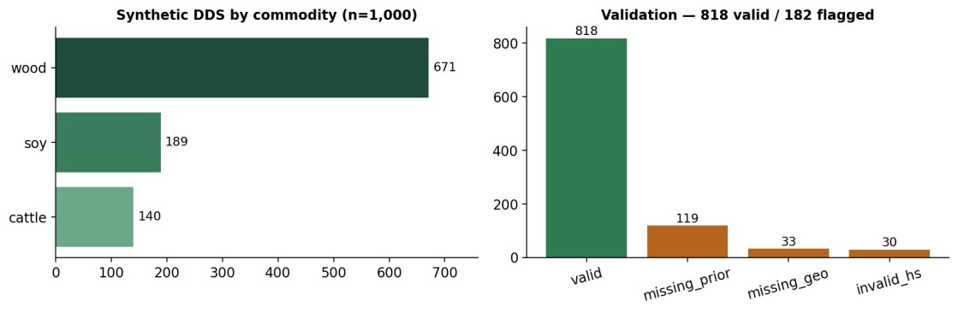
Figure 5 — Composition of the synthetic register and the validation outcome.

5.8 Modelling III: Volume Forecasting
Monthly submission counts were extracted from the database and an ordinary least squares linear trend fitted, giving a growth rate of approximately 1.1 additional statements per month. The linear form was selected deliberately: with a series of 36 monthly observations, a more complex specification would risk fitting noise rather than signal, and the business question, namely how quickly the workload is growing, is answered by a slope. The trend projected twelve months forward reaches approximately 60 statements per month by early 2028. As with the classifier, this selection was tested rather than assumed: five alternative specifications, including simple exponential smoothing, Holt’s linear trend, Holt-Winters additive seasonality and two naive baselines, were fitted on the same series and evaluated on a six-month holdout. Results are reported in Section 6.3. The series fitted trend and projection are shown in Figure 6.

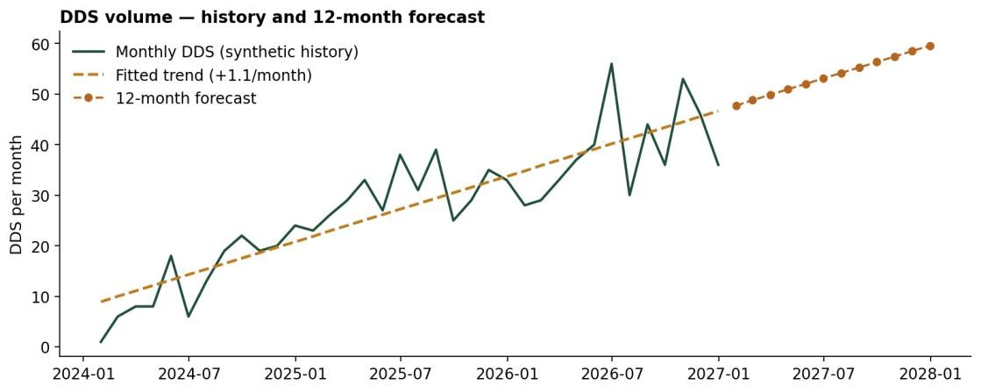
Figure 6 — Monthly DDS volume fitted trend and twelve-month forecast.

5.9 Modelling IV: Machine-Learning Document Extraction (instantiating DP4)
Real statements will arrive as documents rather than as database rows, so the final component addresses automated reading. A document simulator generated 200 realistic statement texts in three distinct phrasing templates from database records, each paired with the record from which it was produced, which serves as the answer key for evaluation.
A two-stage extractor was then built. The first stage uses rule-based pattern matching for rigidly formatted fields, namely the statement reference, HS code, quantity and product description. Rules were chosen over learned models for these fields deliberately: the formats are legally standardised, so a pattern is more reliable than a classifier, and the extraction is fully auditable, which matters in a compliance context. The second stage addresses the commodity, which cannot be determined from format because it depends on the meaning of the product description. Here term frequency–inverse document frequency features were combined with a multinomial naive Bayes classifier, following the combined approach demonstrated by Bommarito, Katz and Detterman (2018) for legal and regulatory text. Naive Bayes was selected for three reasons: it performs well on small training sets, where more complex models overfit; its decisions are interpretable, since the word probabilities behind any prediction can be inspected; and it is the standard baseline the literature recommends before more elaborate alternatives. Training used 140 documents and evaluation used a held-out set of 60 documents that the model had not seen. Because the selection of a simple, interpretable model is a methodological claim, it was tested rather than merely argued. Two further classifiers, logistic regression and a linear support vector machine, were trained on the identical training set and scored on the identical held-out set, and each configuration was additionally assessed under stratified five-fold cross-validation. The comparison was then repeated under a deliberately harder condition, in which the models were trained on one set of product descriptions and tested on an entirely disjoint set they had never encountered, including realistic synonyms such as prime steak and bovine protein in place of the literal term beef. Results are reported in Section 6.3.

5.10 Deployment II: Reporting Layer
The reporting layer was built in Power BI, which was specified by the sponsor because the company operates in a Microsoft environment. Four headline indicators summarise the register at a glance, namely total statements, the proportion valid, the number flagged and the total quantity declared, above four analytical panels: commodity mix, flagged statements by exception reason, validation rate by country of production, and monthly intake with growth trend. The panels cross-filter, so that selecting a commodity re-filters the entire view, allowing the compliance position for a single commodity to be isolated in one action. The dashboard is shown in Figure 7.
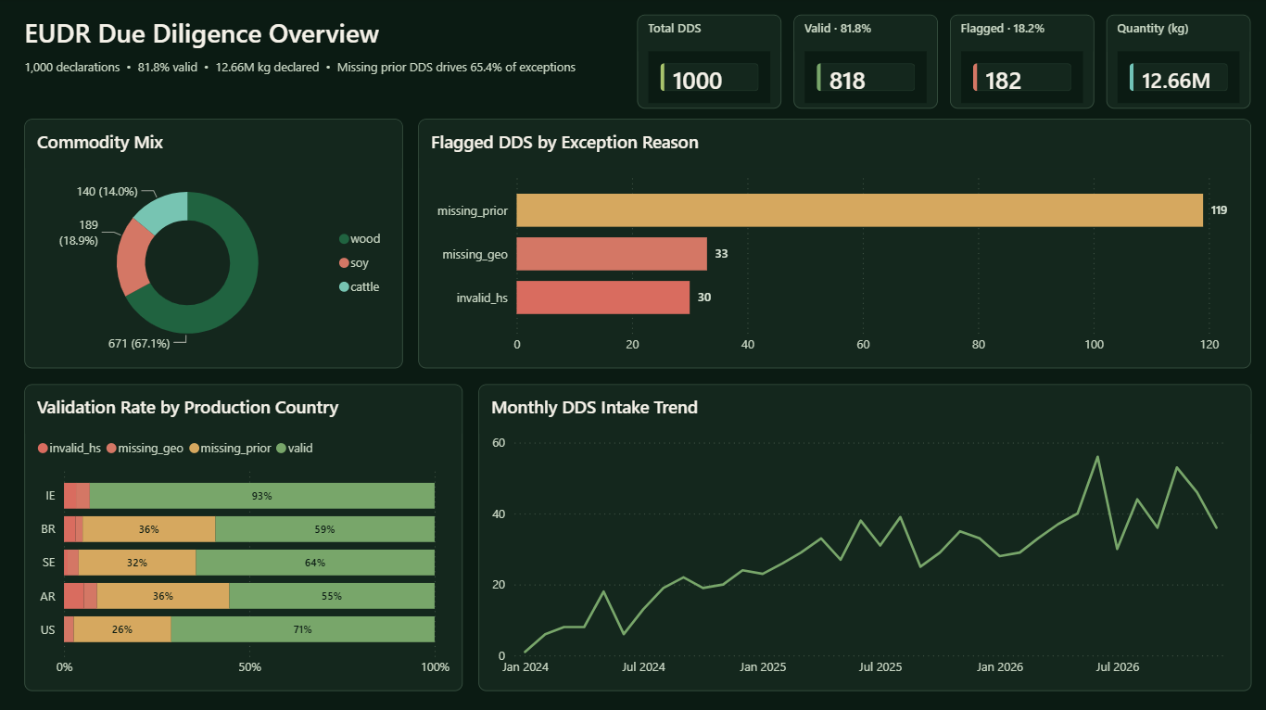

Figure 7 — The Power BI compliance dashboard, showing four cross-filtering panels.

Chapter 6 - Results and Evaluation

6.1 Measured Results
Table 3 summarises the measured outcome of each component.

Component | Measured result
Commodity exposure | 14 of 81 products in scope: 7 confirmed, 4 sponsor-confirmed,  3 market proxy, 1 borderline
Packaging footprint 2024 | Approximately 326 tonnes CO2e across 68 products (c.1,040 t scaled to the full range); 92 per cent wood-derived
Synthetic register | 1,000 records: 671 wood, 189 soya, 140 cattle; reproducible under fixed seed
Validation | 818 valid, 182 flagged (119 missing prior reference, 33 missing geolocation, 30 invalid HS); all seeded faults detected
Forecast | Trend of +1.1 statements per month; approximately 60 per month by early 2028
ML field extraction, 60 unseen documents | Reference 100 per cent; HS code 98 per cent; quantity 100 per cent; description 100 per cent
ML commodity classification | 100 per cent accuracy; confusion matrix diagonal (9 cattle, 10 soya, 41 wood)
Table 3 — Measured results across all system components.
Two observations qualify these figures. First, the single HS-code extraction miss was a deliberately corrupted record, which the extractor correctly declined to read. That behaviour is consistent with the validation layer's flagging of the same record, indicating that faulty data is treated coherently across the pipeline rather than being silently repaired. Second, the perfect classification accuracy partly reflects the limited description vocabulary present in synthetic data, where five distinct product descriptions recur. It is therefore reported as a demonstrated capability rather than as a production guarantee, and accuracy would be expected to fall on the more varied descriptions found in real supplier documentation.

6.2 Triangulation against the Audited Repak Statement
The packaging tonnages computed from the specifications were cross-checked against the company's Repak transparency statement for 2024, an independently audited declaration made for regulatory fee purposes. The two routes are methodologically independent: the computed estimate multiplies component weights by sales volumes from the bottom up, while the Repak declaration reports placings by material. The comparison served two purposes, validating the computed figures and, in the event, identifying and correcting a material error in the calculation basis.
The initial computation multiplied every packaging component by the number of individual selling units sold and produced a total of approximately 13,500 tonnes of packaging material against an audited declaration of 275.5 tonnes. Investigation established that the discrepancy arose from the basis on which packaging weights are recorded in the specification data. The weights are stated per pack rather than per individual selling unit, a distinction that is immaterial for most products but decisive for those sold in bulk multiples. The clearest instance is a sugar sachet line recorded with a case quantity of one thousand and a component weight of two hundred grams: the two hundred grams describes the carton containing one thousand sachets, not each sachet individually. Multiplying by unit count rather than pack count attributed 2,128 tonnes of cardboard to that single product, and five sugar, salt and pepper lines together accounted for 98 per cent of the inflated paper and card figure.
Recomputing on the correct per-pack basis, with tertiary pallet packaging apportioned across the cases carried per pallet, resolves the discrepancy. Wood packaging computes to 5.93 tonnes against an audited 5.887 tonnes, a difference of less than one per cent, and the pallet loading implied by that reconciliation, approximately fifty-one cases per pallet, is consistent with standard practice. The remaining materials fall in the expected relation to the audited figures once coverage is accounted for, as set out in Table 4. The material-mix comparison is shown in Figure 8.
Coverage explains the residual difference in total. The computed estimate covers the 68 products for which both packaging specifications and 2024 volumes are available, whereas the Repak declaration covers the full own-brand range of 231 stock keeping units. The computed total of 86.5 tonnes represents 31 per cent of the audited 275.5 tonnes, against a product coverage of 29 per cent, and the correspondence between these two proportions indicates that the bottom-up method reconciles with the audited declaration once partial coverage is taken into account. On that basis the corrected footprint is 326 tonnes of carbon dioxide equivalent for the products analysed, or approximately 1,040 tonnes scaled to the full own-brand range. Two observations follow. The first is methodological: the error was not detectable from internal consistency, since the calculation was arithmetically correct throughout and the inflated figures were not obviously implausible when viewed in isolation. It was detectable only against an independent source, which is the argument for triangulation as an evaluation method rather than a confirmatory exercise. The second concerns the substantive finding: the wood-derived share of the footprint is 92 per cent on the corrected basis, against 99 per cent under the original calculation. The conclusion that deforestation-relevant materials dominate the packaging footprint is therefore unaffected in substance, which is consistent with the general property that proportional findings are more robust to scaling errors than absolute ones.

Material | Computed (tonnes) | Repak audited (tonnes) | Computed share | Repak share
Paper and card | 68.99 | 176.87 | 79.8 per cent | 64.2 per cent
Wood | 5.93 | 5.89 | 6.9 per cent | 2.1 per cent
Plastic | 9.42 | 61.04 | 10.9 per cent | 22.2 per cent
Steel | 1.95 | 30.29 | 2.3 per cent | 11.0 per cent
Composite and aluminium | 0.17 | 1.44 | 0.2 per cent | 0.5 per cent
Total | 86.46 | 275.53
Table 4 — Material tonnages: computed estimate compared with the audited Repak declaration.

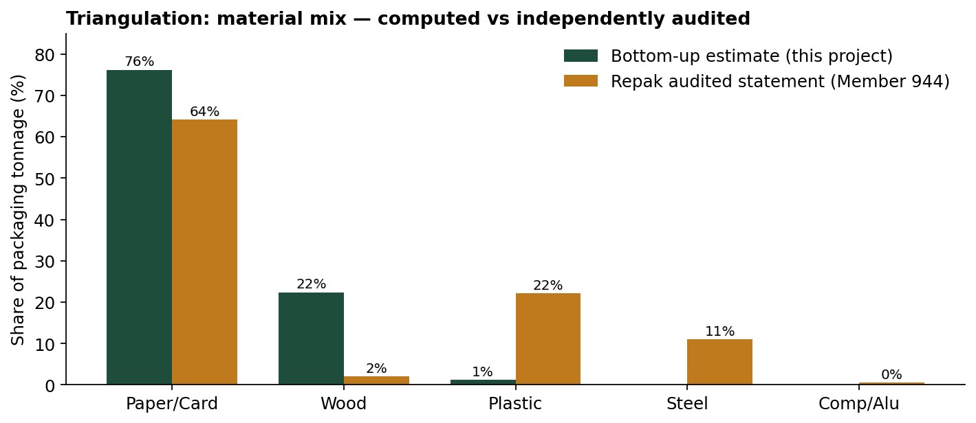

Figure 8 — Material-mix triangulation: computed shares compared with the audited Repak declaration.

6.3 Benchmarking of Modelling Choices
Two modelling choices in this project were made in favour of simplicity: multinomial naive Bayes for commodity classification and an ordinary least squares linear trend for forecasting. Both were justified on methodological grounds in Chapter 5, but a justification is not evidence. This section reports the benchmarking carried out to test whether the simpler specifications are in fact defensible.

6.3.1 Classifier comparison and generalisation
Under the baseline synthetic vocabulary, naive Bayes, logistic regression and a linear support vector machine each achieved 100 per cent accuracy, precision, recall and F1 on the held-out set, with five-fold cross-validation returning 100 per cent with zero standard deviation for all three. That uniformity is itself the finding: the models cannot be distinguished because the task, with five recurring product descriptions, is too easy to discriminate between them. This result quantifies the concern raised in Section 6.1 more precisely than a caveat could.
The comparison was therefore repeated under a stress test in which the models were trained on twelve descriptions and evaluated on fourteen entirely unseen ones, including cattle products described through synonyms such as prime steak, bovine protein and meat and animal derivatives rather than the literal term beef. Accuracy fell from 100 per cent to 78.6 per cent for naive Bayes and for the linear support vector machine, and to 71.4 per cent for logistic regression, with corresponding macro F1 scores of 73.3 per cent, 73.3 per cent and 58.3 per cent. Naive Bayes therefore matches the best-performing alternative while retaining the interpretability that motivated its selection, and the choice is evidenced rather than merely asserted.
The failure mode is informative. All errors fall in a single cell of the confusion matrix: three of four unseen cattle descriptions were classified as wood, the majority class, because none of the substitute vocabulary appeared in training. No wood or soya item was misclassified. The model does not fail randomly under unfamiliar vocabulary; it defaults to the dominant class. For a compliance application, this matters, because such an error would understate cattle exposure specifically, and it identifies vocabulary coverage rather than model architecture as the binding constraint on real-world performance.

6.3.2 Forecast model comparison
Six specifications were fitted on the first thirty months of the series and evaluated on a six-month holdout. Measured by mean absolute error in statements per month, the mean of the last three months performed best at 6.94, followed by the project’s linear trend at 8.09, Holt-Winters additive seasonality at 9.41, simple exponential smoothing at 10.45, Holt’s linear trend at 10.90 and the naive last-value baseline at 15.17. Root mean squared errors follow the same ordering.
Three conclusions follow. First, the linear trend comfortably outperforms the naive baseline, which is the minimum standard any forecast should meet and which had not previously been demonstrated. Second, the more sophisticated exponential smoothing specifications did not improve on it, which supports rather than undermines the original selection: with thirty training observations and no established seasonality, added model complexity captures noise rather than signal. Third, and reported without qualification, a three-month moving average outperformed the fitted trend on this holdout. That result is honest evidence that the linear model is not optimal for short-horizon prediction, although it remains the appropriate choice for the project’s actual purpose, which is to characterise the direction and rate of growth in compliance workload rather than to predict any individual month. Both comparisons are summarised in Figure 9.

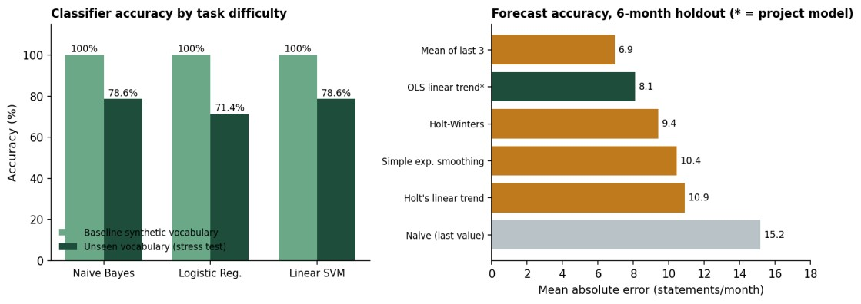
Figure 9 — Benchmarking of modelling choices: classifier accuracy under increasing task difficulty and forecast accuracy on a six-month holdout.

6.3.3 Validation layer as a detector
Because the seeded faults are known, the validation layer can itself be evaluated as a detector. Against the 73 records in which fault injection materially corrupted the data, the layer achieved 100 per cent recall: no effective fault escaped detection. Apparent precision is 43.2 per cent, but inspection shows that every record flagged without having been seeded is an imported consignment genuinely lacking an upstream reference, generated naturally by the thirty per cent probability governing that field. These are therefore not detector errors but genuine compliance gaps in well-formed records, which is precisely the distinction drawn in Section 6.1. Reported against records that are either corrupted or non-compliant, the layer makes no incorrect classification. The measurement nonetheless illustrates a real operational property: a rule-based compliance screen will surface a substantially larger review queue than the population of defective records alone, and staffing should be planned accordingly.

6.4 Evaluation of the Design Principles
Sections 6.1 to 6.3 evaluate the artefact as an instantiation: whether the components work and how well. This section evaluates the design knowledge the artefact embodies, assessing each principle from Section 3.3 against the evidence the implementation produced. This is the evaluation activity of the Design Science Research cycle proper, since it is the principles rather than the instantiation that constitute the transferable contribution.
DP1, tiered evidence provenance, is supported. The principle was tested by an event rather than a metric. In Week 10, the industry supervisor confirmed that the flammable substance in the firelighter range is wood-based, overturning a classification that had rested on market comparison. Because each determination carried its evidence tier, the four affected products were reclassified, the in-scope count revised from ten to fourteen, and the downstream generator reparametrized without any component being rebuilt. Had the classifications been recorded without provenance, the revision would have required re-deriving the entire map. Three classifications remain at the market-evidence tier and are visibly flagged as such, which is the intended behaviour rather than an unresolved defect.
DP2, regulation-derived data structure, is supported. Nineteen fields were derived from Annex II, and the May 2026 simplification package provided an unplanned test of durability: the amendment introduced an estimated annual quantity, a prior statement reference and a country risk classification. Each mapped onto an identifiable field addition rather than requiring structural change, which is the property the principle claims. The corresponding cost is that the model inherits the regulation's own ambiguities, notably its treatment of statements covering multiple plots, discussed in Chapter 9.
DP3, calibrated synthetic instantiation with seeded defects, is supported with a quantified boundary. Calibration held: the generated commodity distribution of 671 wood, 189 soya and 140 cattle statements reproduce the exposure profile independently established in Section 5.2. Seeding enabled measurement that would otherwise have been impossible: because the corrupted records were known, the validation layer could be scored rather than merely demonstrated, returning complete recall as reported in Section 6.3.3. The boundary is equally clear. Section 6.3.1 shows classifier accuracy falling from 100 per cent to 78.6 per cent when vocabulary moves outside the generator's parameters, which establishes that calibrated synthetic data supports development and internal validation but not claims about live performance.
DP4, method allocation by field determinacy, is supported. Deterministic rules extracted the reference, quantity and description fields at complete accuracy and the HS code at 98 per cent, the single miss being a deliberately corrupted code that the rule correctly declined to read. The learned component, confined to the one field whose value depends on meaning, matched the best-performing alternative classifier under stress testing while remaining interpretable. The allocation therefore achieved its intended effect: the great majority of extraction is auditable, and statistical inference is confined to where determinism is unavailable.
DP5, separation of malformity from non-compliance, is supported, and produced the most operationally significant finding of the evaluation. Of 182 flagged records, 63 were structurally defective, lacking geolocation or carrying a malformed code, while 119 were well-formed statements lacking an upstream reference. Section 6.3.3 establishes that the latter are not detector errors: everyone is a genuine compliance gap. A screen that reported a single defect count would have misrepresented the position, since the two categories route to different remedies, the first to data correction with the supplier and the second to escalation of the due-diligence chain. Taken together, the five principles are supported by the implementation, with DP3 carrying an explicit and quantified boundary condition. They are stated at the level of nascent design knowledge rather than design theory, in the terms of Gregor and Hevner (2013): they have been instantiated and evaluated in a single organisational setting, and their transferability beyond that setting is argued analytically in Chapter 8 rather than demonstrated empirically.

Chapter 7 - The EUDR Compliance Analytics Framework

The design principles stated in Section 3.3 and evaluated in Section 6.4 constitute the potentially transferable knowledge produced by this project. This chapter presents their organised expression as the EUDR Compliance Analytics Framework: a prescriptive method by which an operator subject to the regulation can move from an unclassified product range to an operating compliance analytics capability.

7.1 What the Framework Contributes
A distinction must be drawn at the outset, because it determines whether the framework constitutes a contribution or merely a description. The sequence of stages below resembles any analytics pipeline: understand the data, structure it, populate it, model it, report it. That sequence is not the contribution, and no novelty is claimed for it. What is contributed is the design knowledge embedded at four specific points, where the compliance context imposes requirements that a conventional analytics pipeline does not face and would not satisfy.
First, conventional pipelines assume the classification of records is either known or learnable from data. Under EUDR, the classification is a regulatory determination that must be auditable and revisable, and the necessary composition data is routinely unavailable to a distributor. DP1 responds by making evidence provenance a first-class attribute of the classification rather than documentation attached to it, which is what permitted the Week 10 revision to propagate without re-derivation. Second, conventional pipelines derive the schema from the data available or the questions anticipated. DP2 derives it from statutory text, which inverts the usual direction of design and yields a structure that is defensible to a regulator and that absorbs legislative amendment as field addition, as the May 2026 package demonstrated.
Third, conventional pipelines begin when data exists. A compliance system whose obligations commence on a fixed future date cannot wait, and DP3 addresses this by treating calibrated synthetic generation with seeded defects as a development strategy rather than a substitute for data, which additionally yields the ground truth necessary to measure detection at all.
Fourth, conventional pipelines optimise extraction and classification for accuracy. In a regulated setting, an unexplainable determination has limited value, and DP4 accordingly allocates method by field determinacy rather than by performance, confining statistical inference to fields where meaning must be inferred. DP5 completes this by requiring that structural and regulatory defects be reported as distinct conditions, since they route to different remedies.
The framework is therefore not a pipeline with a compliance topic applied to it. It is a set of prescriptive responses to requirements that arise from the regulatory context, arranged in the order in which an adopting organisation would encounter them.

7.2 The Six Stages
Stage 1, Scope. Classify the product range against the regulated commodities using an ordered evidence hierarchy, recording the tier of each determination. Assess product content and packaging separately, since they fall under different regulatory instruments. Output: a classification registers in which inferred and confirmed determinations are distinguishable. Instantiates DP1.
Stage 2, Model. Derive the statement data structure field by field from the governing legal text, establishing the primary key and the referential structure that represents the upstream due-diligence chain. Output: a data model traceable to statute. Instantiates DP2.
Stage 3, Store. Implement the model in a relational structure whose record lifecycle satisfies the applicable retention obligation, implementing removal as archiving rather than deletion. Output: a persistent register. Follows from DP2.
Stage 4, Populate and validate. Where real statements are not yet available, populate the register with synthetic records calibrated to the organisation's operating parameters and carrying seeded defects. Apply deterministic checks derived from the regulation, reporting structural and regulatory defects separately. Output: a validated register with measured detection performance. Instantiates DP3 and DP5. Stage 5, Analyse and forecast. Characterise composition, origin and risk, and project statement volume to inform compliance resourcing. Select model complexity against the decision the analysis supports rather than against error metrics alone, and benchmark that selection. Output: a compliance position and a workload projection. Stage 6, Report and automate. Present the position through an interactive reporting layer and automate document intake by allocating deterministic rules to legally formatted fields and learned models only to fields dependent on meaning. Output: an operating reporting capability with auditable automated intake. Instantiates DP4.

7.3 Conditions of Applicability
The framework assumes an operator that holds product and volume records but not necessarily composition data, that is subject to a statutory instrument specifying the content of a compliance record, and that must prepare in advance of a fixed commencement date. These conditions are not specific to Stonehouse, and to that extent the framework is potentially transferable rather than demonstrably general: they describe the general position of a distributor or retailer under EUDR, and the first, second and fourth are shared by other product-compliance regimes, including the Ecodesign for Sustainable Products Regulation and its Digital Product Passport provisions. Stage 4 is the stage most tightly bound to present circumstances, since the synthetic instantiation becomes unnecessary once real statements accumulate, at which point the stage is read as a validation protocol rather than a generation strategy. Figure 10 presents the implemented pipeline in this light. 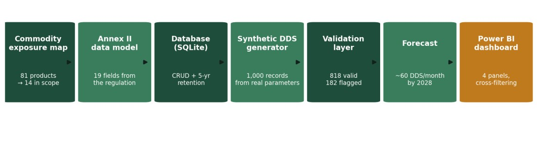 Figure 10 — The implemented pipeline, which constitutes the evidence base for the six framework stages.
Figure 10 — The implemented pipeline, which constitutes the evidence base for the six framework stages.

Chapter 8 - Contribution, Discussion and Limitations

8.1 Contribution to Knowledge
The academic contribution of this project is the set of five design principles stated in Section 3.3 and evaluated in Section 6.4, positioned as nascent design knowledge in the terms of Gregor and Hevner (2013). Their novelty lies in addressing a problem the existing literature has not treated as a design problem. Wibawa et al. (2024) build a traceability system for a single commodity in a producing country, and Rothe et al. (2024) build a compliance tool for coffee; both demonstrate that such systems can be constructed, but neither articulates transferable principles, and both address a single-commodity producer rather than a distributor holding a mixed range for which composition data is unavailable. McDermott et al. (2025) propose a monitoring framework for the EUDR, but at the level of policy evaluation across jurisdictions rather than firm-level compliance operations. The principles offered here occupy the space between prescriptive design knowledge for the operator that must comply, in the specific condition of incomplete composition data and pre-commencement development.
The contribution to practice is distinct from this and should not be conflated with it. For Stonehouse, the project delivers an exposure determination for the full own-brand range, an operating analytics capability that will accept real statements without redesign, a workload projection to inform resourcing, and a set of specific actions set out in Section 9.2. For other operators, the framework of Chapter 7 offers a documented method whose conditions of applicability are stated explicitly.

8.2 Discussion in Relation to Prior Work
Three findings warrant discussion against the literature reviewed in Chapter 2.
The first concerns the availability of classification evidence. The traceability literature, including Reading et al. (2024) and Wibawa et al. (2024), addresses verification at the point of production, where the commodity, the plot and the producer are known, and the analytical problem is confirming a claim about land use. This project encountered a prior problem that literature does not treat at the distribution end of the chain: the operator may not know whether a regulated commodity is present in a product at all. That fourteen of 81 products required a tiered evidence hierarchy, and that four classifications turned on sponsor domain knowledge that no dataset contained, suggests that scoping is a substantive analytical problem rather than a preliminary to traceability. The equity concerns raised by McDermott et al. (2025) acquire an additional dimension in this light: if determining exposure is difficult for a well-resourced EU distributor holding its own product data, the burden on smaller suppliers asked to substantiate those determinations is correspondingly greater.
The second concerns model selection. Hyndman and Athanasopoulos (2021) advise selecting the simplest specification that captures the pattern, and the benchmarking in Section 6.3.2 both supports and complicates that guidance. It supports it in that the more elaborate exponential smoothing specifications did not improve on a linear trend at this series length. It complicates it in that a three-month moving average achieved lower error still, while being incapable of expressing the growth rate that the analysis exists to establish. The finding is that fitness for the decision, rather than error minimisation alone, must govern selection, and that reporting the comparison is what makes such a choice defensible.
The third concerns the limits of synthetic data. The synthetic-data literature supports generation where real data is unavailable, provided the process is documented and reproducible, and Section 6.3.1 supplies a quantification of what that support does and does not extend to. Under the generator's own vocabulary, three classifiers were indistinguishable at complete accuracy; under vocabulary outside it, accuracy fell to 78.6 per cent. Calibrated synthetic data therefore validated the pipeline's integrity but could not establish live classification performance, and the distinction between those two claims is one that reporting of synthetic-data results should make explicit.

8.3 Limitations
The findings bear on the sub-questions set out in Section 1.3 and carry implications for the sponsor and for other operators.
On the first sub-question, the exposure mapping shows that regulatory exposure in a mixed wholesale range is both narrower and more concentrated than might be assumed: 14 products of 81, and within those, a heavy concentration in wood-derived lines. The practical implication for the sponsor is that due-diligence effort can be directed at a small, identifiable subset of suppliers rather than across the entire own-brand range. The methodological implication is more general. Classification could not be completed from product data alone, and the evidence hierarchy developed in response, in which product identity ranks above domain knowledge and domain knowledge above market comparison, is a transferable device for any operator facing the same absence of ingredient-level specification. The firelighter reclassification in Week 10 demonstrates its value in practice: a market-based inference was overturned by sponsor knowledge, the change was traceable because the evidence tier was recorded, and the map was revised without disturbing anything downstream.
On the second and third sub-questions, deriving the data model directly from Annex II proved to be the decision that simplified everything that followed. Because the schema is the regulation expressed as a table, each field is defensible by reference to the legal text, and the validation rules follow from the same source rather than from analyst judgement. The validation results also illustrate a distinction that matters operationally: of the 182 flagged records, those lacking geolocation or carrying malformed codes are data-quality faults, whereas those lacking an upstream reference are compliance gaps in otherwise well-formed records. A system that conflated the two would either over-report defects or miss genuine exposure. The forecast, meanwhile, converts a regulatory abstraction into a resourcing question: a growth rate of approximately 1.1 statements per month means the compliance workload roughly doubles over two years, which is a planning input rather than a compliance finding.
On the fourth sub-question, the framework is potentially transferable because its stages are defined by the regulation rather than by Stonehouse's circumstances. Any operator must scope its range, model the statement, store it, validate it, analyse it and report on it. What differs between firms is the content of each stage, not its existence. The relationship to the wider regime is also visible in the results: the finding that 92 per cent of the packaging footprint is wood-derived shows that the
EUDR lens and the packaging and carbon lens fall on the same material streams even though they are governed separately, which supports the sponsor's instruction to assess both while keeping the regimes distinct. As stated in Section 6.4, this transferability is argued analytically rather than empirically demonstrated, since the framework has been instantiated and evaluated in a single organisational setting.

Five limitations qualify the findings. First, and most fundamentally, the system has never processed a real Due Diligence Statement, because none yet exist. The claim supported by this work is that the framework demonstrably ingests, validates, analyses, forecasts and reports on statements structured as the regulation requires, not that it has been proven in live operation. Second, the synthetic data reproduces the assumptions built into its generator. The rising volume trend is an assumption about supplier onboarding rather than an observation, so the forecast demonstrates capability rather than predicting real intake.
Third, the machine-learning results are optimistic by construction. The synthetic documents contain five distinct product descriptions across three phrasing templates, which is a narrower vocabulary than real supplier documentation would present. The benchmarking in Section 6.3 quantifies this: under unseen vocabulary, classification accuracy falls from 100 per cent to 78.6 per cent, with errors concentrated in cattle descriptions that use synonyms absent from training. The headline figure should therefore be read as an upper bound, and the realistic expectation on live documentation lies closer to the stress-test result. Fourth, the carbon footprint uses sector-average emission factors, which the input-output literature identifies as suitable for screening rather than for product-level claims, and its absolute scale is additionally subject to the Repak declaration-boundary question discussed in Section 6.2. Fifth, three exposure classifications rest on market-equivalent evidence rather than on supplier confirmation, and one product remains borderline; these are flagged in the register rather than resolved, and confirmation from suppliers would be required before the map is relied upon for filing.
Two narrower simplifications should also be recorded. The data model holds one geolocation per statement, whereas a real statement may cover multiple plots and would require a separate plots table in production. The forecasting model is linear and therefore cannot represent seasonality or the saturation that would be expected once supplier onboarding completes.

Chapter 9 - Conclusions and Recommendations

9.1 Conclusions
This project asked how a data-driven framework could be designed to identify deforestation-risk commodity exposure and to track and analyse Due Diligence Statements for a food wholesaler's own-brand range. The answer is the six-stage EUDR Compliance Analytics Framework presented in Chapter 7, evidenced by a working implementation. Fourteen of Stonehouse's 81 own-brand products were identified as in scope, concentrated in wood-based and pet-food lines. A database derived from Annex II was populated with 1,000 reproducible synthetic statements, of which an automated validation layer cleared 818 and flagged 182. A forecasting model projects intake of approximately 60 statements per month by early 2028, and a machine-learning extractor reads statement documents at 98 to 100 per cent field accuracy. A supporting analysis established that 92 per cent of the packaging carbon footprint is wood-derived, a proportion corroborated by independent audited data.

9.2 Recommendations for the Sponsor
Four recommendations follow. First, obtain supplier confirmation for the four classifications that currently rest on market-equivalent evidence, so that the exposure map can be relied upon for filing. Second, clarify the Repak declaration boundary and the treatment of reuse packaging, which would resolve the scale question identified in Section 6.2 and allow the footprint estimate to be finalised. Third, plan compliance capacity against a growing rather than a steady workload, since the forecast indicates sustained growth in statement intake. Fourth, begin collecting supplier documentation in advance of December 2026, since the extraction component can be trained on real documents as soon as they become available and its accuracy on real vocabulary can then be measured.

9.3 Future Work
Four extensions would strengthen the artefact. Re-evaluating the extractor on real statements once they arrive would replace the demonstrated capability with a measured production figure. Extending the data model to a separate plots table would accommodate statements covering multiple parcels. Replacing the linear forecast with an exponential smoothing specification would capture seasonality and saturation once sufficient history exists. Expanding the training vocabulary is now identifiable as the highest-value improvement to the extractor, since Section 6.3 shows vocabulary coverage rather than model architecture to be the binding constraint on accuracy. Finally, incorporating geospatial verification of the kind demonstrated by Reading et al. (2024), in which satellite imagery is used to test deforestation-free claims against the supplied plot coordinates, would extend the system from checking that statements are complete to testing whether they are true, which is the natural next step beyond the present scope.

References

Bommarito, M.J., Katz, D.M. and Detterman, E.M., 2018. LexNLP: natural language processing and information extraction for legal and regulatory texts. arXiv preprint arXiv:1806.03688. DOI: https://doi.org/10.48550/arXiv.1806.03688
European Commission, 2021. New EU Forest Strategy for 2030. COM(2021) 572 final. Brussels: European Commission.
European Commission, 2026. Deforestation Regulation implementation: guidance document and frequently asked questions. Brussels: European Commission.
European Parliament and Council, 2018. Regulation (EU) 2018/841 on the inclusion of greenhouse gas emissions and removals from land use, land use change and forestry, as amended by Regulation (EU) 2023/839. Official Journal of the European Union, L 156, pp.1-25.
European Parliament and Council, 2023. Regulation (EU) 2023/1115 on the making available on the Union market and the export from the Union of certain commodities and products associated with deforestation and forest degradation. Official Journal of the European Union, L 150, pp.206-247.
Eurostat, 2008. NACE Rev. 2: statistical classification of economic activities in the European Community. Luxembourg: Office for Official Publications of the European Communities.
Gilbert, C.L., 2024. The EU Deforestation Regulation. EuroChoices, 23(3), pp.64-70. DOI: https://doi.org/10.1111/1746-692X.12436
Gregor, S. and Hevner, A.R., 2013. Positioning and presenting design science research for maximum impact. MIS Quarterly, 37(2), pp.337-355. DOI: https://doi.org/10.25300/MISQ/2013/37.2.01
Hevner, A.R., March, S.T., Park, J. and Ram, S., 2004. Design science in information systems research. MIS Quarterly, 28(1), pp.75-105. DOI: https://doi.org/10.2307/25148625
Hyndman, R.J. and Athanasopoulos, G., 2021. Forecasting: principles and practice. 3rd ed. Melbourne: OTexts.
McDermott, C.L., Addoah, T., Agyarko-Kwarteng, T., Asare, R., Assanvo, A., Bastos Lima, M.G., Bellfield, H., Berlan, A., Carodenuto, S., Gardner, T., Garrett, R.D., Hafferty, C., Hirons, M., Ingram, V., Kumeh, E.M., Lyons-White, J., Mason, J., Meyfroidt, P., Montana, J., de Oliveira, G.L.T., Ramcilovik-Suominen, S., Sotirov, M., Thompson, W. and Winkel, G., 2025. Equity in unilateral value chain policies: a monitoring framework for the EUDR and beyond. Forest Policy and Economics, 174, 103469. DOI: https://doi.org/10.1016/j.forpol.2025.103469
Merciai, S. and Schmidt, J., 2018. Methodology for the construction of global multiregional hybrid supply and use tables for the EXIOBASE v3 database. Journal of Industrial Ecology, 22(3), pp.516-531. DOI: https://doi.org/10.1111/jiec.12713
Peffers, K., Tuunanen, T., Rothenberger, M.A. and Chatterjee, S., 2007. A design science research methodology for information systems research. Journal of Management Information Systems, 24(3), pp.45-77. DOI: https://doi.org/10.2753/MIS0742-1222240302
Reading, I., Bika, K., Drakesmith, T., McNeill, C., Cheesbrough, S., Byrne, J. and Balzter, H., 2024. Due diligence for deforestation-free supply chains with Copernicus Sentinel-2 imagery and machine learning. Forests, 15(4), 617. DOI: https://doi.org/10.3390/f15040617
Rothe, P., Celik Schoreels, I., Phuntsho, P. and Henke, J., 2024. EUDR Coffee Check: a tool to support the coffee sector to become compliant with the European Union regulation on deforestation-free products (EUDR). Proceedings, 109(1), 21. DOI: https://doi.org/10.3390/ICC2024-18160
Singh, R., Siddiqui, A.A. and Prasad, S.S., 2025. EU deforestation regulation and green disclosures: India's evolving governance architecture. International Journal of Disclosure and Governance. DOI: https://doi.org/10.1057/s41310-025-00316-0
Stadler, K., Wood, R., Bulavskaya, T., Sodersten, C.J., Simas, M., Schmidt, S., Usubiaga, A., Acosta-Fernandez, J., Kuenen, J., Bruckner, M., Giljum, S., Lutter, S., Merciai, S., Schmidt, J.H., Theurl, M.C., Plutzar, C., Kastner, T., Eisenmenger, N., Erb, K.H., de Koning, A. and Tukker, A., 2018. EXIOBASE 3: developing a time series of detailed environmentally extended multi-regional input-output tables. Journal of Industrial Ecology, 22(3), pp.502-515. DOI: https://doi.org/10.1111/jiec.12715
Wibawa, J.C., Utomo, M.E., Bachtiar, V.H., Radliya, N.R. and Fauzan, R., 2024. Palm oil commodity traceability system to support the implementation of EUDR policies in Indonesia. In: 2024 International Conference on Informatics Engineering, Science & Technology (INCITEST). IEEE.
WRI and WBCSD, 2011. Corporate value chain (Scope 3) accounting and reporting standard. Washington, DC: World Resources Institute and World Business Council for Sustainable Development.

APPENDIX

Appendix A - Project Timeline
The project ran from May to August 2026 against the capstone schedule. Table 5 records the work completed in each period.

Week | Dates 2026 | Work completed | Deliverable
2 | 25-31 May | Kick-off; initial meeting with academic and industry supervisors; objectives, scope, deliverables and  technical approaches agreed | Learning journal 1
4 | 8-14 June | Literature review and data gathering; research divided across the team; the five sponsor datasets profiled | Learning journal 2
6 | 22-28 June | Literature consolidated into thematic pillars; synthesis matrix established; problem statement, research question and methodology specified. | Learning journal 3
8 | 6-12 July | Data preparation and prototyping: exposure map, Annex II data model, database, 1,000 synthetic statements, validation layer, forecast and Power BI dashboard | Learning journal 4
10 | 20-26 July | Model implementation and evaluation: sponsored-driven reclassification of firelighters to 14 of 81 in scope; schema documentation with key structure; two-stage extractor built and measured | Learning journal 5
12 | 3-9 August | Results and analysis; Repak triangulation completed; afforestation review added; draft report prepared | Learning journal 6 and draft report
14 | 17 August | Final write-up and poster | Capstone report
15 | 24 August | Oral defence | Presentation
Table 5 — Project timeline and deliverables by week.

Appendix B - Additional Materials

Appendix B - Additional Materials

The following materials support this report and are held in the project repository at https://github.com/soundhar-veerapandian/stonehouse-eudr-capstone, where each is available in the folder indicated.
B1 - Commodity-exposure register (data/). The full 81-product register, recording for each product its classification, the commodity identified where applicable, the evidence tiers on which the determination rests, and the supporting rationale.
B2 - Pipeline source code (src/). The complete Python implementation, comprising the data model, database implementation, synthetic generator, validation layer, forecasting model and document extractor.
B3 - Synthetic register (data/). The generated dataset of 1,000 Due Diligence Statements, reproducible from the specification in Appendix C.
B4 - Power BI dashboard (dashboard/). The reporting layer shown in Figure 7, provided as a .pbix file requiring Power BI Desktop.

Appendix C - Synthetic Data Generation Specification

This appendix documents the generation of the synthetic Due Diligence Statement register described in Section 5.6, in sufficient detail for the dataset to be reproduced exactly. Generation is implemented in Python and is available in the project repository as dds_generator.py.
Reproducibility. The pseudo-random number generator is seeded with the fixed value 42 before any draw is made. Every figure reported in this report regenerates identically from this seed.
Volume and period. One thousand statements are generated across 36 months from 1 January 2024 to 31 December 2026.
Commodity and product assignment. Each statement is assigned a commodity and product by weighted draw, with weights derived from the exposure register of Section 5.2: toilet tissue rolls, wood, HS 4818, weight 45; fire logs, wood, HS 4401, weight 20; beef pet food, cattle, HS 2309, weight 15; complete dog food, soya, HS 2309, weight 15; soybean oil blend, soya, HS 1507, weight 5. The resulting distribution of 671 wood, 189 soya and 140 cattle statements reproduces the exposure profile, which is the calibration claim of DP3.
Supplier assignment. Suppliers are drawn uniformly from six names taken from the sponsor's own supplier records.
Country of production. Countries are drawn by weighted probability conditioned on commodity: wood, Ireland 80, Sweden 15, Brazil 5; cattle, Ireland 90, Brazil 10; soya, Brazil 50, Argentina 30, United States 20. Risk classification follows the Commission country benchmarking: Ireland, Sweden and the United States low; Brazil and Argentina standard.
Geolocation. Coordinates are generated as the centroid of the assigned country perturbed by a uniform draw of plus or minus 1.5 degrees in each of latitude and longitude. These are simulated coordinates and are marked as such throughout; in a real statement they would be supplied by the producer.
Quantity. Net quantity is drawn between 500 and 25,000 kilograms uniformly. Estimated annual quantity is the net quantity multiplied by a uniform draw between 8 and 14.
Temporal distribution. The submission date is determined by drawing a uniform random value, raising it to the power 0.6, and scaling to the days. The exponent produces a distribution skewed toward later dates, representing progressive supplier onboarding toward the commencement date, and is the assumption underlying the growth trend detected in Section 5.8. The production date precedes submission by a uniform draw of between 30 and 120 days.
Upstream reference. A prior statement reference is present with probability 0.7 and absent otherwise, representing consignments for which no upstream statement has been supplied.
Defect seeding. Each record is designated defective with probability 0.10, and each defective record is assigned one defect type drawn uniformly from three: absent geolocation, in which latitude and longitude are set to null; malformed HS code, in which the third character is replaced by the letter x; and absent upstream reference, applied only where the country of production is not Ireland, since the corresponding validation rule applies only to imports. This last condition means a proportion of designated defects are inert, and Section 6.3.3 reports detection against effective rather than designated defects for that reason.
Known limitations of the generator. The product description vocabulary comprises five distinct strings, which is narrower than real supplier documentation and is the source of the optimistic classification result quantified in Section 6.3.1. Each statement carries a single geolocation, whereas a real statement may cover multiple plots. Quantities are drawn independently of product identity and do not reflect product-specific volume patterns.

Glossary of Terms

Commodity regulated — One of the seven commodities named in the EUDR: cattle, cocoa, coffee, oil palm, rubber, soya and wood.
Derived product — A product made using a regulated commodity, such as leather, chocolate, tyres or furniture, listed in Annex I of the regulation.
Due Diligence Statement — The declaration an operator submits confirming that due diligence has been carried out and that the risk of non-compliance is negligible. Operator — A person or firm placing a product on the Union market for the first time, or exporting it, who carries the full due-diligence obligation.
Trader — A person or firm in the supply chain other than the operator, subject to lighter record-keeping obligations.
Deforestation-free — Produced on land not subject to deforestation after 31 December 2020.
Seeded fault — A deliberately introduced error in the synthetic dataset, used to measure detection performance against a known answer key.

